Fire Fighting Robot

Supervisor:-
Prof Kavi Arya

Submitted by:-
Amitkumar Patil-113050034
Jayanta Das-11305R012

Index

S.No. | Content | Pg.No.
1 | Problem Statement | 3
2 | Desired Specifications | 3
3 | Materials required | 4
4 | Functional Requirements | 5
5 | Implementation | 6-8
7 | Discussion of system | 8-9
8 | Future work | 10
9 | What we learnt? | 10-11
10 | Conclusion | 11
11 | References | 11

Problem Statement

The aim of the project is to make a robot which can follow a black strip on a white floor and can extinguish the fire on the destined room in a building. The robot can be used in the rescue operation also. Thus the robot can act as a path guider in normal case and as a fire extinguisher in emergency.

Design Specifications
- For proper functioning of the robot needs a voltage supply of about 5.3V and current about 0.7A.
- The robot should be able to distinguish between the white and the black surface.
- If the black surface suddenly ends, the robot should keep on moving in the direction it last moved until the black line is again there.
- It should stop and extinguish fire and restart only after making sure that the fire has been extinguished.

Material Required

The component list for making the robot is as follows:-

S.No | Material Required | Description | Quantity
1 | Spark 5 | Robot | 2
2 | Zigbee module | Wireless communication | 4
3 | Plywood sheets (3*3 ft) | For construction of 2 floor building model | 2
4 | Accessories for modeling lift | Modeling lift for the building | 1 set
5 | Dc motor | Driving the lift assembly | 1
6 | connectors | Driving the motor through robot | 1

Functional requirements

- Fire fighting robot should know the path to lift from its parking place.
- Lift controller robot should be able to move the lift to the commanded floor.
- Fire fighting robot should be able to find its path to the room on fire.
- PC (Master controller) should be able to communicate the room no on fire to robot (fire fighting ), the floor no which is on fire to robot (lift controller robot) & coordinate the movements of both the bots.
- Every room has a fire sensor and there is a mapping between (floor no, room no) and sensor no.
- The (floor no, room no) which is on fire has to be communicated to PC (Master controller).
- Due to difficulties in construction fire sensor mapping hardware & interfacing it with PC, the above two requirements have been abstracted to
- The (floor no, room no) is read from user on PC.
- Once the robot reaches the room which is on fire, it is assumed that fire has been extinguished.

Implementation

Algorithms for robot control
Because the floor plan is fixed and the occurrence of the fire can be considered random, the robot can be programmed to traverse the house in a specific room order. The entire program operation is straightforward: Wait for the instruction from master pc, then proceed to commanded room. Once the fire has been successfully extinguished, the robot will return to the starting location for reduction in time for next operation.

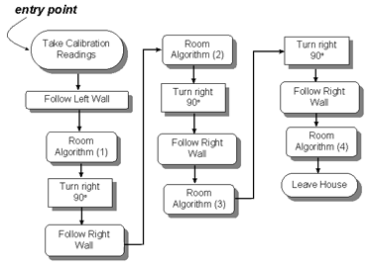
Figure 1 (program flowchart for this operation)

In order for the robot to accomplish the above tasks, it must first navigate through the hallways in order to find a room. Ideally, the robot must be able to find its way into a given room from any location in the building. Figure 2 demonstrates how this is to be accomplished. Simply put, the robot is able to follow a given wall by comparing sensor readings with the calibration readings. If the robot determines that it is too close to the specified wall, it sets the motor directions and turns away from the wall. Similarly, if the robot is too far from a wall, it will set the motor directions and turn toward the wall. Although this may seem like a poor control method, the small steps of the stepper motors provide a seemingly fluid robot movement. A relatively simple means of navigating the entire building, then, is to simply follow a given wall until a room has been entered. As mentioned before, this condition can be detected when the floor sensor picks up the white line marking the room doorway.

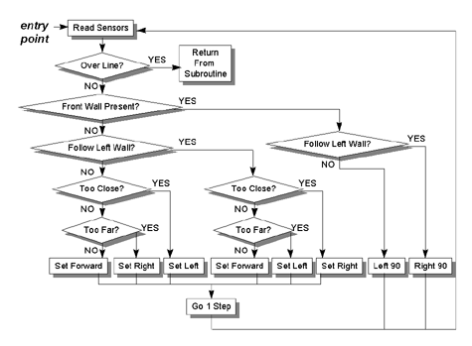
Figure 2 Flowchart room finding Algorithm

Once the robot has found its way into a room, it must then determine and extinguish the fire present. Then the robot can move to next room on the same floor (if its on fire) or can return to its starting point.

The time taken for the robot to reach the fire and extinguish it ranged from 25 seconds in the first room to 30 seconds in the fourth room. The worst case scenario would be approximately 65-70 seconds per trial. These results demonstrate that the robot can accomplish all desired tasks while performing reliably.

Discussions of system

The two-wheel design allows the robot precision movement by using stepper motors while also keeping control simple. Proximity sensing is accomplished though the use of IR phototransistors. The devices work well in allowing the robot to determine how far it is from the walls in any given direction up to a distance of approximately 6 inches. The rechargeable batteries (for the motors and logic circuits, respectively) have been tested under full load and are capable of supplying the robot with enough power to complete all of its trials. Furthermore, the program code written for the Atmega 16 microcontroller is capable of moving the robot through the model building without touching any walls. It can enter each of the rooms. Once is has navigated the entire building and put out the fire, the robot will the navigate back to the starting position.
At this point in time, though, the primary task left to be completed is continued development of program code. In certain portions of the building, the robot does not move efficiently (that is, it moves out of its way from black line or does not take commands as expected). As the program code improves, though, the robots performance improves. The existing code however successfully accomplished all necessary tasks for project.
Applications:-
- The robot can be used as a guider to guide the visitors from the entrance to the main office .
- It can help doctors to carry the medicines from one ward to another .
- The main purpose can also be to rescue the people by extinguishing fire in a building .

Future Work
This robot can be turned into multipurpose robot, few possible applications are presented here
- Theft monitoring robot
- Surveillance robot
- Other simple tasks like newspaper dispatching, laundry collection/returning or other tasks which require traversing every room.
- This project can be extended to work across buildings .

What We Learnt

- Working on robot was in itself a great pleasure and satisfaction.
- We learnt the implementation of the big circuit using the basic small circuits.
- The step wise execution of the algorithm/program helps to reach the goal quickly and more accurately.
- The team work is the most important thing we learnt.
- Never lose hope.
- There is a huge difference between the theoretical and the practical world.
- We learnt to work under the supervision and guidelines of our professors.

Conclusion
We believe that our project will be beneficial for various purpose and hence our efforts will be fruitful.

References

http://e-yantra.org
http://www.wikipedia.org
http://www.cse.iitb.ac.in/~cs684/
Spark 5 documentation
Spark 5 hardware and software manuals
Spark 5 standard examples

